1.What is computer programming. Difference between top down approach and bottom up approach.
Ans:
Computer programming is the process of designing, writing, testing, and maintaining instructions, called code, that a computer can follow to perform specific tasks.
Top down approach | Bottom up approach
This approach focus on breaking up the problems into smaller parts | This approach focus on solving smaller problems and integrate as a whole
It is mainly used by structured programming language | It is mainly used by object oriented programming language
Each part is programmed separately therefore contains redundancy | Redundancy is minimized by using data encapsulation and data hiding
Communication is less among modules | Here, modules must have communication
In this approach decomposition takes place | In this approach composition takes places

2. WAP to swap values of two variables without using third variable.

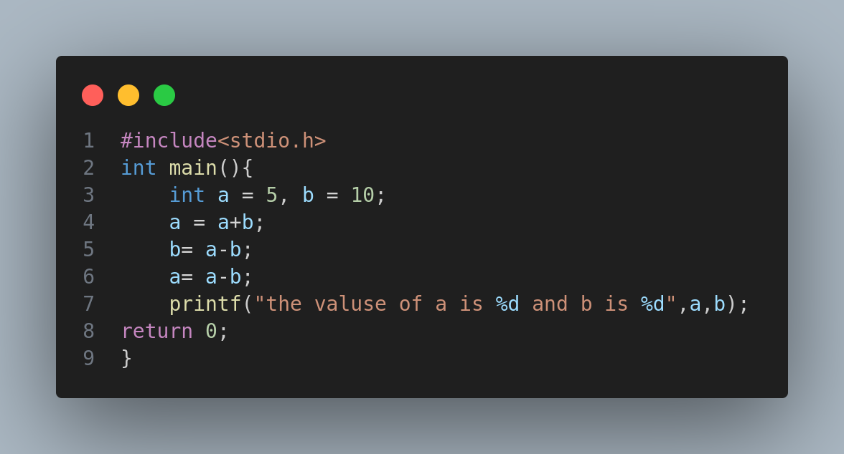

3. WAP to find the roots of quadratic equation
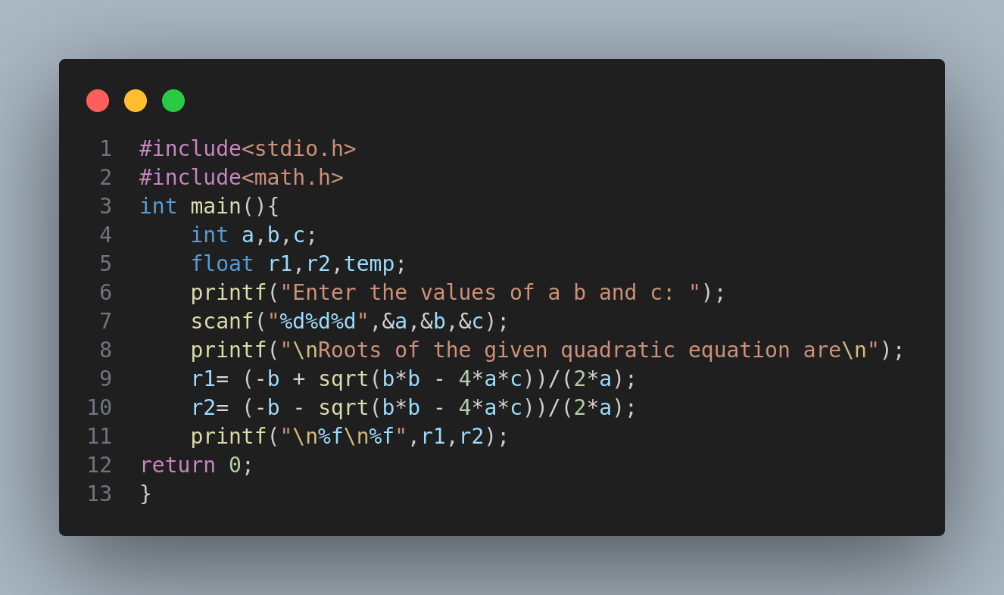

4.Why is array required in programming? WAP to enter age of 30 employees and find the greatest.
Ans: Array is required in programming because it allows user to store multiple values of same data type in a single variable. It is also cache friendly as a result it improves the performance. Instead of declaring separate variables for each value (e.g., int a1, a2, a3, ...), you can use an array (e.g., int arr[100];).
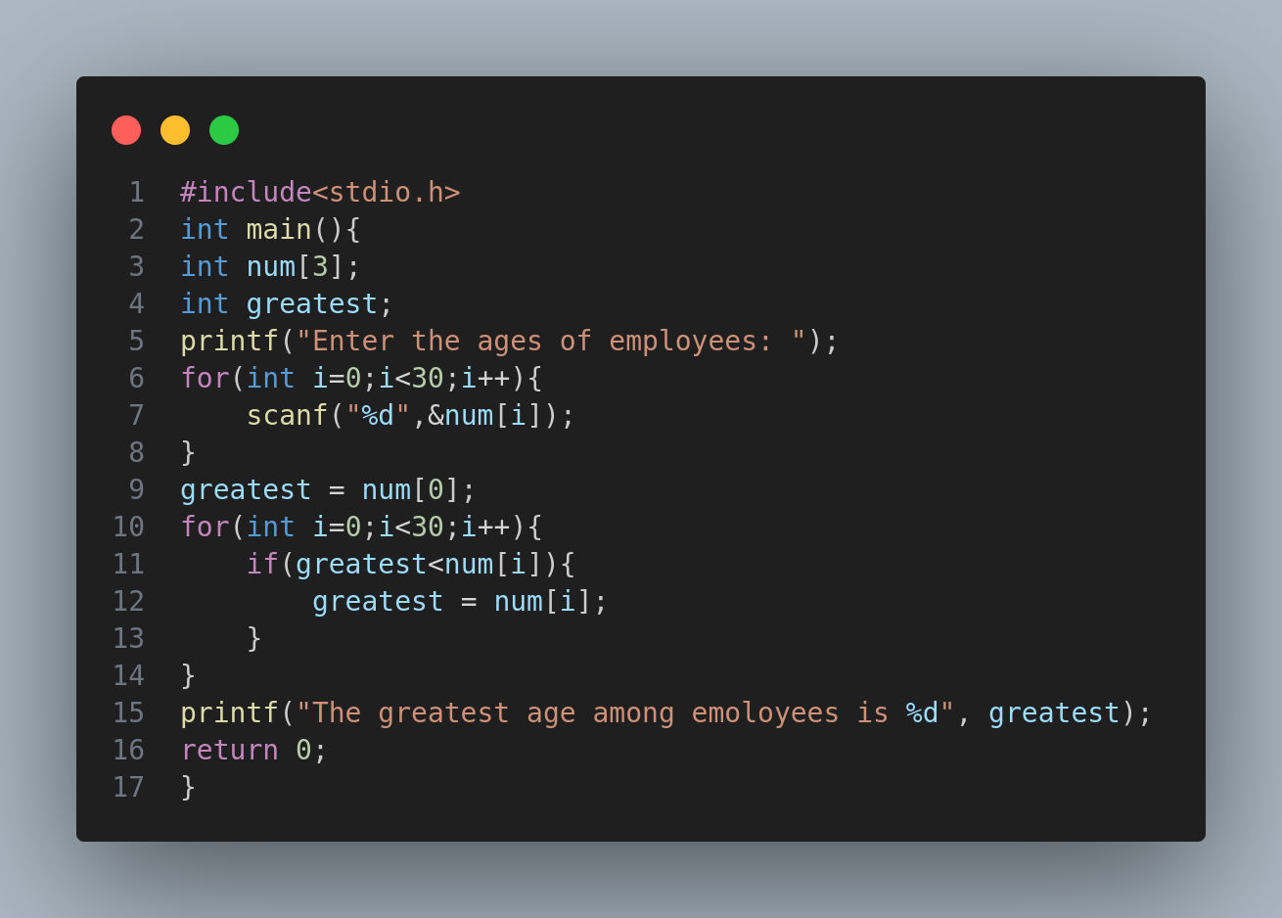

5.What is recursive function. Write a program to generate Fibonacci series using recursion.
Ans: Recursive function are the functions that calls itself directly or indirectly during the execution process to solve a problem.

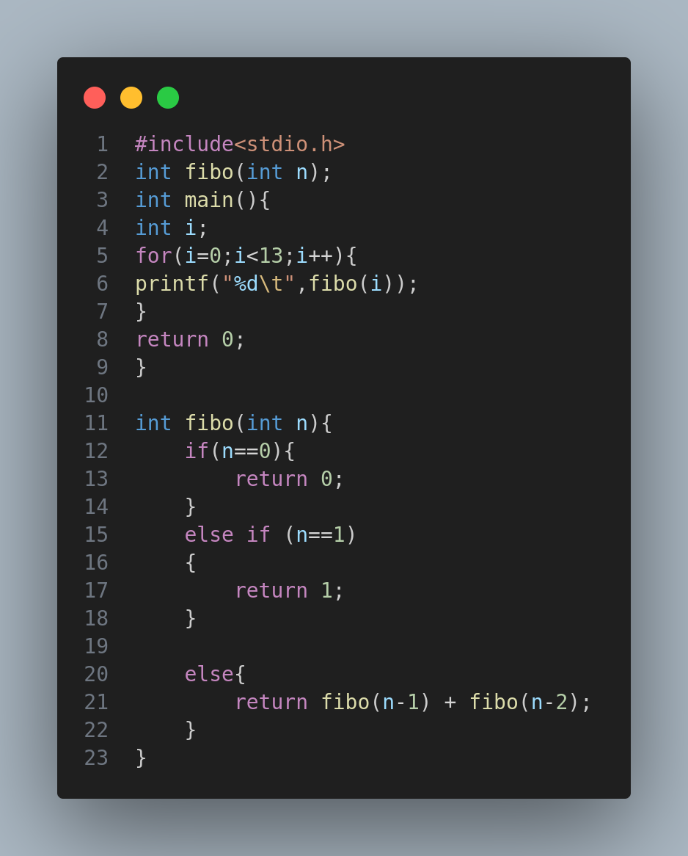

6. What is the advantage of pointer.
Ans : Pointer is a special type of variable that stores the address of another variable where information can be found. Its advantages are as follows:
1. it allows you to directly access and manipulate the memory location.
2. It is essential for DMA(Dynamic Memory Allocation)
3. It saves the memory space and make execution faster.

WAP to store 10 integer and find min and max using DMA.

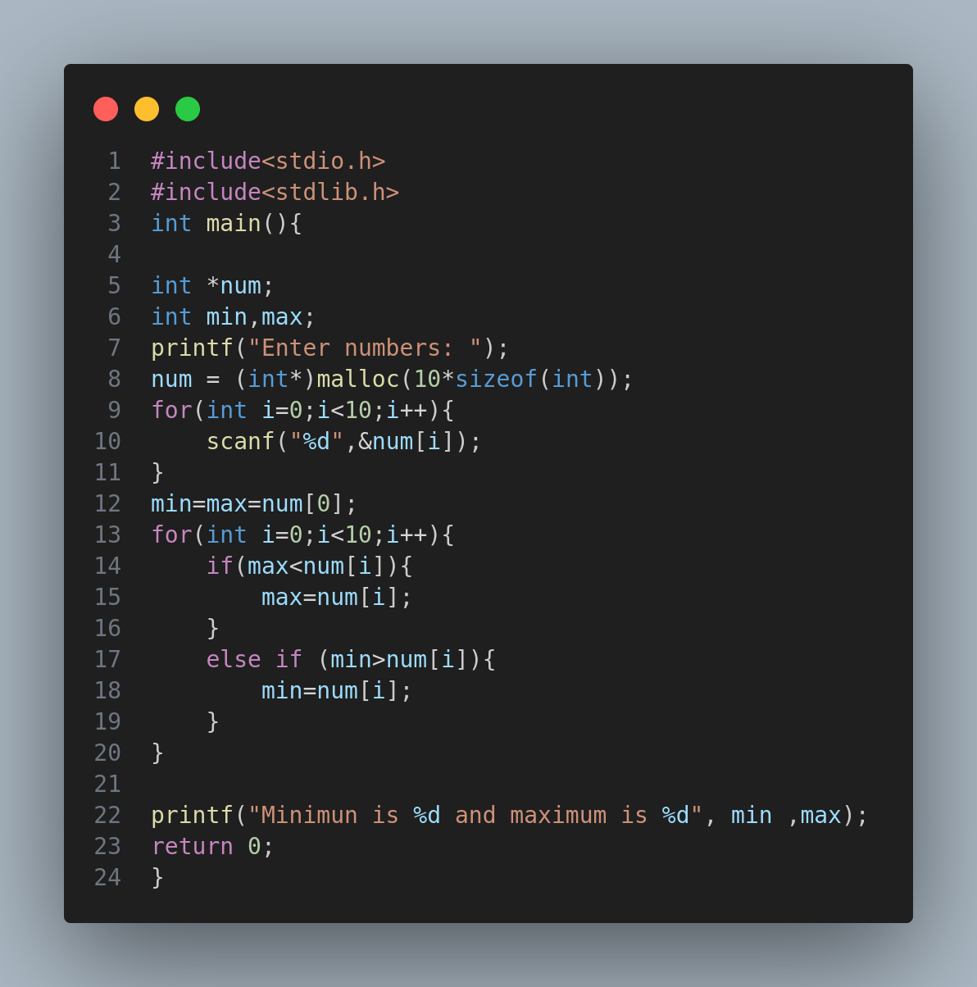
7. what is software development life cycle. Explain Waterfall model advantage and disadvantage.
Ans : Software development life cycle is the process of developing, designing and testing high quality software. It aims to produce a high-quality software that meets or exceeds customer expectations, reaches completion within times and cost estimates.

Waterfall model is the simplest software development life cycle model, where the phases are in linear order ( one after another ).
Advantages
1. Easy to understand
2. Each phases has well defined inputs and outputs
3. Helps the project manager in proper planning the project

Disadvantage
1. Difficulty in accommodating change after the process in underway because of sequential nature.
2. Inflexible partitioning of the project into different stages.
3. Difficult to respond to changing customer requirements.

